We have achieved our Primary Science Quality Mark 2024! Congratulations to all the children and staff for an outstanding achievement. Our hard work, dedication, and passion for science have truly paid off, and this recognition is a testament to the effort and commitment we have all put into fostering curiosity and learning in the field of Science.

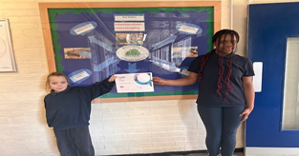 | 

